Preferred payment method for international students
Santa Ana College has partnered with PayMyTuition for international application payments. With PayMyTuition, you can pay your application fees from any bank, in any country in any currency at better than bank exchange rates. PayMyTuition is fast, simple, and cost-effective.
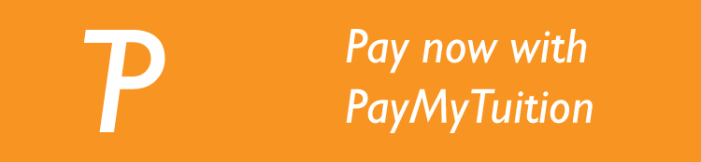
https://payment.paymytuition.com/paynow/sac-app

Additional Information of PayMyTuition:
- Frequently Asked Questions
How to make a payment – step-by-step PDFs:
- English
- French
- Spanish
- Portuguese
- Vietnamese
- Japanese
- Korean
- Traditional Chinese / Simplified Chinese
- Arabic
- Punjabi
- Hindi
- Farsi
- Turkish
- German / Bernese German
- Swedish
- Dutch

PayMyTuition customer support information
Call 1.855.663.6839 (toll-free) or through one of their local country contact numbers. You can also reach PayMyTuition Support at support@paymytuition.com or through their support page.
No matter what time zone you are in, you will have a dedicated customer support team available to you through live chat, email and phone to answer any of your questions and help you make your payment.

